PRESS RELEASE

EUCAN-Connect PROJECT KICK-OFF MEETING RELEASE
Groningen, 21 March 2019

On 7th and 8th March, the EUCAN-Connect project held a successful kick-off meeting in Groningen, the Netherlands. This five-year European H2020 project with one Canadian and twelve European partners will enable large-scale integrated cohort data analysis for personalized and preventive healthcare across EU and Canada.

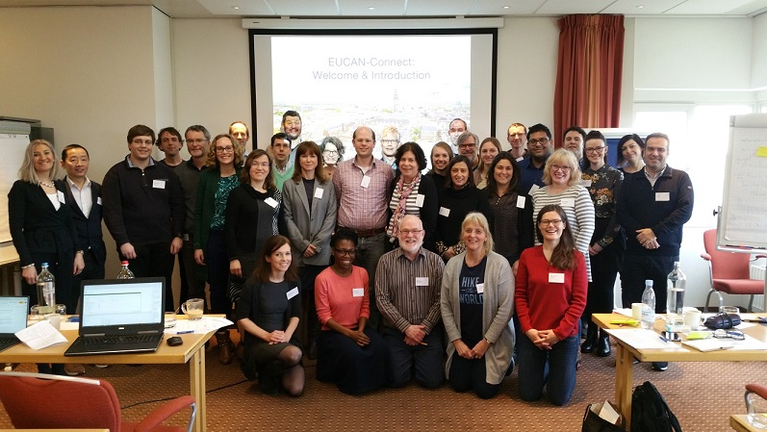

Rapid progress in information and biotechnologies incite the promise of better, personalized prevention and healthcare. To make steps towards a more personalized health available for every citizen, combined analyses of large datasets is crucial. To enable these analyses safe data sharing is essential. Currently, the massive amount of the data from biobanks and cohorts are locked in repositories distributed around the world. For instance, the repositories have no universally compatible data standards and formats, and experience difficulties to share the data because of privacy protection and data security issues and the lack a universal data infrastructure.

EUCAN-Connect will be novel and ground-breaking showcase of a common data infrastructure to enable large-scale integrated analysis of the individual, environmental, population and omics data. This will be based on an open, scalable data platform for cohorts, researchers and networks, incorporating FAIR principles (Findable, Accessible, Interoperable, Reusable) for optimal reuse of existing data, and building on maturing federated technologies, with sensitive data kept locally and only results being shared and integrated, in line with key ELSI and governance guidelines. A multidisciplinary team of the consortium includes leading international epidemiologists, clinicians, fundamental researchers, bioinformaticians, software engineers, cohort operators and data experts synergizing the best elements of major international cohort network and research infrastructure initiatives.

The kick-off meeting was organized to publicly announce the beginning of the EUCAN-Connect project. The main goal of the meeting was to clarify the expectations of everyone, outline the deliverables contents and provide an overview on the project’s framework of activities and plans. The stakeholder engagement and the project benchmark challenges were highlighted, and work packages leaders explained their roles and responsibilities. Partners also discussed and talked through various parts of the EUCAN project and agreed on common goals and results.

EUCAN-Connect Partners :
- University Medical Center Groningen (UMCG), Nederland (Project Coordinator)
- The Research Institute of the McGill University Health Centre (RI MUHC), Canada
- The Chancellor, Masters and Scholars of the University of Cambridge (UCAM), UK
- Newcastle University (UNEW), UK
- Erasmus Medical Center (ERASMUS), Nederland
- Biobanks and Biomolecular resources Research Infrastructure - European Research Infrastructure Consortium (BBMRI-ERIC), Austria
- Copenhagen University (UCPH), Denmark
- Epigeny (EPIGENY), France
- Instituto de Engenharia de Sistemas e Computadores, Tecnologia e Ciência (INESC TEC), Portugal
- Barcelona Institute for Global Health (ISGLOBAL), Spain
- Oulun Yliopisto (University of Oulu), Finland
- Stichting VUMC (VUMC), Nederland
- Instituto de Saúde Pública da Universidade do Porto (ISPUP), Portugal

Contact
Project Coordinator and Project manager:
Prof.dr. Morris Swertz & Dr. Jana van Vliet
Genomics Coordination Centre,
Department of Genetics
University Medical Center Groningen
Hanzeplein 1, 9713 GZ Groningen
The Netherlands
Tel: +31 50 3617100
E-mails: m.a.swertz@umcg.nl ; j.v.van.vliet@umcg.nl

